Bluetooth4.0 Smart Ready
Low Energy USB Adapter
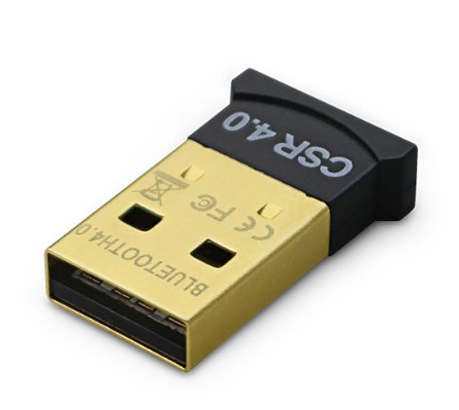
BT-USB-M5

The smart way to connect
Stylish and compact in design, the new BT-USB-M5 is the next generation of BluetoothTM USB adapters that takes advantage of the LE (low energy) standards which means your battery powered devices such as notebooks go the extra distance, while still connecting to your devices at the highest possible speeds with of course, full data security.
Totally BluetoothTM Smart Ready compatible means you can seamlessly connect to the next generation of exciting BluetoothTM Smart Ready devices including wireless stereo speakers, keyboards and a host of future Smart Ready wearable technology from leading vendors.

Features
- BluetoothTM version 4.0 low energy
- CSR8510 or equivalent chipset
- Class-2 up to 30 metre range
- Supports version 4.0, version 2.1, EDR
- High-speed USB - Plug n' Play
- Supports Smart Ready lifestyle devices
- Compact, stylish design
- Compatible with MicrosoftTM WindowsTM XP/Vista/Windows7TM
- Compatible with MicrosoftTM WindowsTM8 - 32/64-bit editions
- Compatible with Mac OS X (10.6.x or higher)

